Table of Contents

1. Introduction 3

2. Requirements to Launch Digital Bank 3

3. Financial Strategy Framework 4

4. Funding Requirements 4

5. Source of Finance 5

6. Advantages and Disadvantages of Financing Model and Funding Cycle Recommendation 6

7. ESG Strategy 7

8. Business Model Canvas 8

9. Financial Tools 9

10. Additional Issues 10

References 10

Appendix 11

Appendix 1 11

Appendix 2 11

Appendix 3 12

Appendix 4 12

Appendix 5 12

Appendix 6 13

JPS-BANK Business Plan

# Introduction

The business that will be developed is a digital bank using blockchain technology called JPS-Bank. Opening JPS-Bank can solve many problems that traditional banks are having. First are security matters, blockchain utilises encryption techniques which means the transaction and data stored will be secured and it would be difficult for hackers to steal any information. Second is efficiency, blockchain can speed up processes in banking and lower the time and expense associated with transaction processing. It will also eliminate the need for customers to wait for a long time and inconvenient banking hours. Third is cross border payments, blockchain technology can help speed up and lower the cost of cross border payments, especially for individuals and small businesses. The target market audience for JPS-Bank will be vary starting with SME owners, international customer, millennials, and techie. See Appendix 1 for additional information.

# Requirements to Launch Digital Bank

When launching JPS-Bank, there will be several requirements that need to be fulfilled. Launching a digital bank takes significant financial resources to cover operational costs and support ongoing operations and growth, JPS-Bank must have access to enough funding, and a strategy to generate revenue. Digital banks must comply to several laws and regulations pertaining to financial institutions. JPS-Bank will ensure to have a thorough understanding of the legal and regulatory framework that applies to the digital bank business to avoid large fines, penalties, and reputational harm. Building JPS-Bank will depend heavily on technology, so it can offer efficient and secure online banking services. To protect consumer data and transactions, JPS-Bank will have a strong technical infrastructure that includes a mobile app, an online banking platform, and cybersecurity protections. A wide variety of skills and talents are necessary to build and operate a digital bank with blockchain technology, including developing software, financial operations, managing risks, marketing, and customer service. JPS-Bank will ensure the team has the required abilities and expertise. JPS-Bank will be unique to differentiate the services with traditional banks and other competitors such as making use of blockchain technology to acquire customers and retain them. See Appendix 2 for additional information.

# Financial Strategy Framework

The financial strategy framework will involve 3 main things, identifying the cost, choosing the source of finance, and building a plan to manage the financial starting from launching. Identifying the costs involved to open and operate JPS-Bank will be the first step in creating a financial strategy. Costs of operation will be for building a technological infrastructure, developing the software, regulatory compliance, hiring and training the employee, marketing purposes, as well as recurring operations costs. After identifying the cost to run the digital bank, JPS-Bank will identify the source of funding from pre-seed stage until round funding. In pre-seed, JPS-Bank will rely on family and friends, and personal savings. In the seed funding stage, JPS-Bank will use angel investors financing model because they usually invest when businesses are starting or in the initial development stage, and they also can give some directions and guidance to run the business. In the series stage of funding, venture capital will be the financing model since they usually invest more money than angel investors. The last strategy in the financial framework will be managing the financial plan after the cost of operation and source of funding has been identified. The plan will implement a financial reporting system that covers the amount of costs or expenses and projects the amount of revenues and profitability expected in return.

# Funding Requirements

There are three main things that are required to build a digital bank namely, licence for regulations, infrastructure, and operational cost (Bahri, 2019). This is the breakdown of the funding requirements JPS-Bank needs.

1. Regulatory Compliance

* E-money licence is required to operate the digital money that will be offered by JPS-Bank. The initial funding required to have an EMI licence is around £300.000. See Appendix 3 for additional explanation.
* Banking licence will be the key factor to provide any kind of banking services such as giving loans and mortgages. The initial minimum value required to have a banking licence is around £ 4.4 million. The banking licence can come later in a series stage of funding since the capital needed is high.

1. Technological Infrastructure

* Core Banking System is where the process of banking services will operate such as account creation, balance checking, transaction, loans, also where the customer data will be stored. The cost of the technology is around £200.000 and will be higher when the amount of customers is increasing.
* Compliance Software is important since it will monitor any activities done by the customer to ensure there are no illegal activities such as illegal money transfer and money laundering (Bahri, 2019). The cost of compliance software will be around £150.000.

1. Operational Cost: Salary and benefits, rent and utilities, as well as regular maintenance and technological upgrades, are all continuing operational costs for digital banks. The total expenses for this will be around £ 700.000.
2. Marketing and advertising will also be the key and need an investment approximately £ 50.000.

# Source of Finance

In order to grow and expand JPS-Bank, the funding cycle that the company will face in different stage of funding will be:

* Pre-seed: This is the earliest stage of startup where the capital that will be needed is small amounts. In this stage, JPS-Bank will rely on friends and family to take loans and personal savings. In this stage, the majority of the funds will be for developers to build the MVP.
* Seed: This is the next stage where JPS-Bank will continue and keep developing the prototype to be launched to the market. In this stage, JPS-Bank will approach angel investors to raise more capital. Attending startup events and working with accelerators will be the way of approaching the potential angel investors.
* Series-A: In this stage, JPS-Bank will already have a fully functional prototype to be launched into the market. A significant amount of capital will be needed to scale up the business and compete with competitors. The source of funding will be changed in this stage from angel investor to venture capital since they offer more capital for business to grow. Before approaching the VC, JPS-Bank will evaluate and build a sustainable business plan and a strong pitching deck. After that, attending a startup and networking events will be the key to meeting potential VC and pitch the idea to get the investment.
* Series-B and Above: In this stage, the capital that will be needed to raise will be for expanding JPS-Bank to a new market and to develop a new product to compete with competitors. The source of finance in this stage will still be VC. The key of approaching investors in this stage is to have a solid track record. JPS-Bank will guarantee from pre-seed until series funding that the business will have considerable growth and traction.

# Advantages and Disadvantages of Financing Model and Funding Cycle Recommendation

In the pre-seed stage of funding, the source of finance will come from family and friends. The first advantages of choosing this finance model are they can offer a low or even free interest rate, second is they will not ask for the high ROI, third, a business plan that will be presented does not need to be detailed. The disadvantages of this model will be any misunderstanding can lead to broken relationships, also they might interfere with the business although they do not have any expertise in the field (NIBUSINESSINFO, 2016).

In the seed stage of funding, the financing model is angel investors. Choosing angel investors brings some advantages. First, angels will be the strongest sources of funding for JPS-Bank due to their willingness to take risks and flexibility. Second, JPS-Bank does not need to pay interest because angel investors provide start-up capital in exchange for a share of the company. Third, angels have knowledge to run the business since most angel investors are experienced investors, they offer professional assistance, connections, and direction that can help the business to thrive. Choosing angel investors can also bring some disadvantages such as, business can get out of control if JPS-Bank decides to give too much equity and angel investors expect a significant amount of ROI from their initial investment within small period of time (Harper James Solicitors, 2022). Therefore, JPS-Bank will only rely on angel investors as the source of funding in seed and choose other sources of funding for later stages.

In the series funding stage, the company will approach venture capitalists to invest in the business. The first advantages of VC are JPS-Bank may receive a lot of capital more than angel can provide. Second is venture capital investment will become an opportunity for JPS-Bank to use their network. While establishing the business, JPS-Bank will lack time to concentrate on networking to support business growth. Having a large network provided by VC may assist in business development, customer acquisition, and future fundraising. Third is the company will grow even quicker by the capital raised from the VC because rapid growth is essential to outpace competitors and secure market share. On the other hand, the disadvantages of using VC funding are the ownership stakes in the business as well as control and decision-making authority can be lost, therefore, the amount of equity that will be offered to the VC will not be too high to mitigate this risk. Venture capital funding can be expensive and can affect the profitability and cash flow of the company. (Fleitmann, 2022)

Going further, the recommendation of the funding cycle for JPS-Bank will be Series C and IPO. Series C will provide the capital for JPS-Bank to continue growing and expanding out into other markets. JPS-Bank expected to be generating a significant profit at this point and have positioned itself as the industry leader. The funds raised from the Series C round will be invested in new technologies, the product range will be expanded, and new markets will be entered. JPS-Bank may consider going for an initial public offering (IPO) once it has grown and become a market leader. Through an IPO, JPS-Bank can raise visibility and reputation in the market. See appendix 4 for additional information.

# ESG Strategy

Environmental, Social, and Governance (ESG) standards have become more significant in business, and this is especially relevant for the financial services sector, which includes digital banking. Due to their value in building trust among customers and investors, ESG standards are significant in the world of digital banking. Examples of environmental factors include a company's effect on usage of resources, waste management, and climate change. JPS-Bank can minimise the environmental impact and show some concerns regarding the environment by applying sustainable practices and utilising renewable energy sources. Social elements may include JPS-Bank’s concerns with employee’s well-being, diversity, and community involvement. Prioritising social issues can help JPS-Bank to attract and keep the best employees, creating a positive environment, and demonstrating the company commitment to social responsibility. Additionally, it might improve brand reputation and increase customer retention. Transparency and ethical conduct are examples of governance-related aspects. JPS-Bank can demonstrate the commitment to ethical behaviour by stopping fraud along with other financial crimes and guarantee regulatory compliance by putting strong governance policies and procedures into place. As a result, JPS-Bank can gain more trust from the customers and investors, and it can increase the business sustainability. Having ESG standards can impacts JPS-Bank in many ways such as:

* JPS-Bank may develop an excellent track record and brand image that can help stand out in a competitive marketplace by showing a commitment to ethical and sustainable practices.
* By considering ESG, JPS-Bank can detect and mitigate potential risks that may negatively impact the financial performance, reputation, and legal compliance. JPS-Bank will prioritise data privacy and cybersecurity to avoid cyberattacks and data breaches that could lead to financial losses, reputational harm, and legal consequences.
* These days, investors are placing more emphasis on ESG factors. JPS-Bank can raise funds from investors who seek responsible investment by showing them that ESG factors are the top priority. JPS-Bank could get an advantage over the competitors and to raise the capital required to develop and expand the businesses.

# Business Model Canvas

See Appendix 5 for additional explanation.

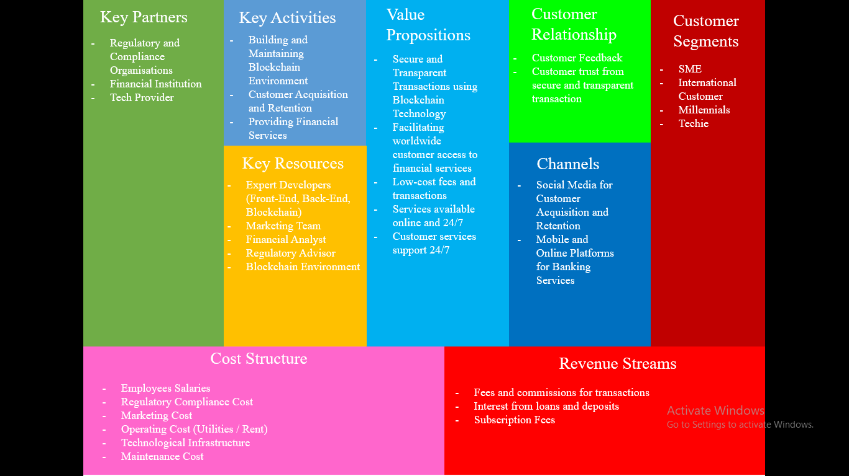

# Financial Tools

1. Break Even Analysis

The purpose of the research by Alnasser et al (2014) was to determine if utilising break even points in planning, controlling, and decision-making impacted those processes. The implementation of the break-even analysis in planning, control, and decision-making are statistically significantly correlated. Due to its significance, effectiveness, and precision in the rationalisation and management of decisions, the study has advised that businesses should use break-even analysis as their primary instrument for decision-making and planning oversight. (Alnasser et al., 2014)

1. Budget

Pavlatos & Kostakis (2021) investigate how the use of budget and financial performance correlate in the context of start-up businesses. The results of this study demonstrate there is a positive relationship between financial performance and the use of budgets for planning, resource allocation, and performance evaluation. In start-up businesses, planning has a significant impact on how budgets are utilised (Pavlatos & Kostakis, 2021).

1. Revenue Projection

Investors can better comprehend the company's growth potential by looking at the company's revenue projection for the coming few years. Investors may determine from revenue predictions how much the company plan to sell and how quickly the company expect sales to increase. This tool is crucial because investors want to know how the company evaluated growth and cost, so they can speak regarding the numbers and the assumptions that were provided to them (Canaree, 2020).

1. Cash Flow Analysis

The cash flow statement provides information on the company’s cash inflow and outflow. The CFS helps investors in determining how much liquid is available for the business to cover its operational expenses and pay its debts. Investors value the CFS equally since it tells them of a company's financial stability and decide on their investments. (Murphy, 2023)

1. Valuation Analysis

Valuation analysis help investors provide investors of how much the business is valued and how much equity will they get in return for their investment (Hayes, 2021). To value a business the company could times the annual revenue by 2 or EBITDA by 10.

# Additional Issues

There are several issues that will be crucial for JPS-Bank to survive and generate more profit. Building a user-friendly platform that is easy to use and easy to access for customers to access their financial accounts and services should be a top priority for management. Blockchain technology is developing rapidly, therefore it's crucial for JPS-Bank to stay updated on the most recent developments to differentiate from competitors. JPS-Bank could also establish partnerships with other fintech companies to expand product offerings and maintain competitiveness in a market.

Word Count from Introduction until this part is: 2468.

See Appendix 6 for the Powerpoint Presentation to pitch.

# References

Bahri, G. (2019, December 19). *How to Build a Digital Bank from Scratch...& The Economics!* Retrieved from LinkedIn: https://www.linkedin.com/pulse/how-build-digital-bank-from-scratch-economics-germain-bahri/

Canaree. (2020, December 22). *Why a financial projection slide is vital to your startup pitch deck*. Retrieved from Canaree: https://www.canaree.co/blog/why-a-financial-projection-slide-is-vital-to-your-startup-pitch-deck

Fleitmann, M. (2022, August 26). *Pros And Cons Of Venture Capitalists: A Complete Guide*. Retrieved from BaseTemplates: https://www.basetemplates.com/blog/pros-and-cons-of-venture-capitalists

Harper James Solicitors. (2022, February 2). *Business angels: advantages and disadvantages*. Retrieved from Harper James : https://harperjames.co.uk/blog/business-angels-advantages-and-disadvantages/

NIBUSINESSINFO. (2016). *Financing from friends and family*. Retrieved from NIBUSINESSINFO.CO.UK: https://www.nibusinessinfo.co.uk/content/advantages-and-disadvantages-raising-finance-friends-and-family

Alnasser, N., Shaban, O. S., & Al-Zubi, Z. (2014). The effect of using break-even-point in planning, controlling, and decision making in the industrial Jordanian companies. International Journal of Academic Research in Business and Social Sciences, 4(5), 626.

Pavlatos, O., & Kostakis, H. (2021). Budgeting in start-up companies: European survey-based evidence. In Advances in Management Accounting (Vol. 33, pp. 97-125). Emerald Publishing Limited.

# Appendix

## Appendix 1

Target Audience Further Explanation:

• SME Owners: JPS-Bank could be appealing to small company owners because of the advantages of increased efficiency and security. SME that wants to accelerate their operations and lower the risk of fraud will be interested in a digital bank that uses blockchain to automate and protect financial transactions.

• International Customer: Blockchain technology offers faster and safer cross-border transactions, individuals who frequently travel or work abroad may be drawn to a digital bank that utilises blockchain technology.

• Millennials: JPS-Bank could be appealing to younger generations that are comfortable with technology and regard transparency.

• Techie: Individuals with an interest in emerging technologies can be attracted to use digital banks that make use of that technology like blockchain. Also, people who work in the tech sector or other sectors where blockchain is being implemented or explored may also be fascinated by this invention.

## Appendix 2

Operational Cost: building technical infrastructure, paying salary, and complying to legal requirements.

Laws that the company need to comply to build a digital bank: banking licence requirements, know-your-customer (KYC), and anti-money laundering (AML) regulations, as well as laws protecting confidential data or privacy.

## Appendix 3

EMI (E-Money Licence) will let customers create an account or an e-wallet, so they can store money on their mobile device or anywhere online. These e-wallets can handle any kind of features similar to payment services, including transfers and card transactions.

## Appendix 4

Angel investors make an investment using their own wealth and they frequently have a good track record of running a successful business and they are aware of the risks associated with starting a business.

VC funding can be expensive since significant shares of stock, management fees, and other charges involved with the investment.

## Appendix 5

The business model canvas for JPS-Bank will cover aspect from key partners that will tell some of the partners or potential partners, key activities will tell what will JPS-Bank do or what services will JPS-Bank provide, key resources will tell the resources needed in order to accomplish the activities, value proposition will tell what solution are JPS-Bank bringing to the people, customer segments will tell which will be the potential customers or who will use this product, customer relationship will tell how JPS-Bank interact with the customers, channels will tell how JPS-Bank promote and market the product, cost structure will tell the operational expenses in order to run the business, and revenue streams tell how JPS-Bank will get revenue.

## Appendix 6

10 Slides to pitch.

